Robotics and Feature Engineering
Learning Objectives:
- Determine the outputs needed to achieve a goal.
- Implement algorithms to process raw sensor data into action outputs.
- Gather sensor data to validate whether goal criteria is achieved.

Note: Read chapters 1-26 in Artificial Intelligence: A Modern Approach before beginning this lesson.

CoppeliaSim
In this lesson you explore the CoppeliaSim environment, a virtual robot kit that will also be used in your performance assessment.

Download CoppeliaSim. CoppeliaSim edu is free for students and appropriate for the learning activities and performance assessment in this course.

Read about the main features within the CoppeliaSim User Manual, and browse the remaining sections of the manual. Bookmark the User Manual for easy access.

Open CoppeliaSim, and follow along with the BubbleRob Tutorial within the Tutorials section of the CoppeliaSim User Manual. Familiarize yourself with the other provided tutorials. Further support is available within Coppelia Robotics Resources.

Robotics: Feature Engineering
The following exercise takes you step-by-step through the feature engineering process for robots. For each activity, draft your own response and then compare it to the example response provided. While the wording and content will differ, check to determine whether your response is as thorough and accurate as the example. Then review the Assessment Connection comments for tips on applying these ideas within Task 2. Complete this exercise in preparation for Task 2.

Mission to Europa
NASA is preparing a mission to send a robotic rover to explore Europa, one of Jupiter's largest moons. The rover will investigate many scientific objectives, seeking to expand humankind's understanding of this icy world. The finished rover will be a very complex robot, but its foundation is the familiar BubbleRob. NASA has issued a call to computer scientists worldwide: Help make the rover a success by engineering one feature—a goal-seeking behavior that makes use of at least one sensor to support the mission's discoveries.

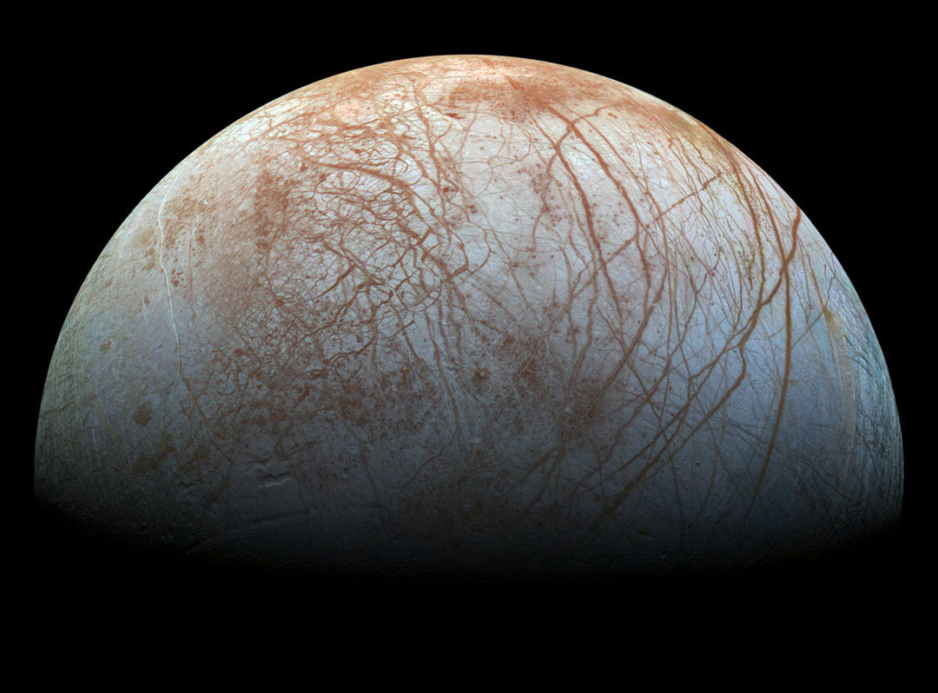
Europa. Image credit: NASA/JPL-Caltech/SETI Institute

Brainstorming Features
Open CoppeliaSim and load the BubbleRob tutorial. Explore the different sensors that you can easily add. Consider overall scientific objectives that the mission might investigate and reflect on how each sensor might support one of these objectives. Start broad by defining an overall objective, then list the specific goal-seeking behaviors and sensors that would contribute to the objective.

Write your objective and specific supporting features.

Example
There are many possible answers. Here is one example.
Scientific Objective: Photograph objects encountered on Europa's surface
- Feature 1: BubbleRob's goal is to reorient itself to directly approach the nearest object, as determined by a proximity sensor.
- Feature 2: BubbleRob's goal is to slowly approach an object, pausing when it is 10 meters away, 6 meters away, 3 meters away, 2 meters away, and 1 meter away from the object, as determined by a proximity sensor.
- Feature 3: BubbleRob's goal is to take photographs of an object while BubbleRob is stationary when it is 10 meters away, 6 meters away, 3 meters away, 2 meters away, and 1 meter away from the object, as determined by a proximity sensor.
- Feature 4: BubbleRob's goal is to choose whether an object warrants further investigation by testing against preestablished criteria the photographs captured by an image sensor.

Note
Subsequent exercises will build on Feature 1; you may practice using this feature for the most direct comparisons, or pursue a different feature for expanded practice.

Assessment Connection: When you are ready to start on Task 2, begin with a similar brainstorming approach. Identify a particular disaster relief objective, and then narrow down specific features that will help achieve this objective. Keep in mind BubbleRob's capabilities and what you will realistically be able to achieve.

Describing the Problem that You Solve
Consider the feature that you have decided to build. What specific problem does it solve? How does this support a broader scientific objective? In what specific context or contexts is this applicable?

Example
Rover Environment
The rover will explore the surface of Europa, a moon of Jupiter. Europa's "surface is smooth and bright, consisting of water ice crisscrossed by long, linear fractures" (NASA Planetary Science Division, n.d., para. 1). "Bright plains are separated by dark bands, which are possible indications of crustal spreading" (European Space Agency, 2011, p. 24). While the rover may visit various areas of Europa's surface, this robotic feature is intended for use on the bright, smooth plains of water ice.

References

European Space Agency (2011, December). JUICE: Exploring the emergence of habitable worlds around gas giants: Assessment study report. Retrieved January 10, 2018 from ESA Science & Technology website, http://sci.esa.int/juice/49837-juice-assessment-study-report-yellow-book/

NASA Planetary Science Division (n.d.). "Europa: In depth." Retrieved January 10, 2018 from Solar System Exploration website, https://solarsystem.nasa.gov/planets/europa/indepth

Assessment Connection: While a fully-functional disaster recovery robot may need to function in many different environments, choose and describe one specific context on which to focus in your work.

Scenario Environment

Example:
The scenario in which BubbleRob operates is a flat plain (approximating the near-flat smooth ice plain of Europa) with four different objects located in various places on the plain.

Update the environment in V-REP to match this example, or modify it as you deem appropriate to match the scenario environment in which you will test the feature you develop.

Assessment Connection: Describe the scenario environment in which you will test your disaster recovery robot prototype, and explain why it is a valid approximation of the disaster recovery environment in which the robot is intended to function. Make sure to update the BubbleRob environment to match your description!

Explain how the rover will support a scientific objective in this particular environment.

Example:
Humankind does not know what to expect out on the plains of Europa, so it will be important to get a look at whatever the rover comes across. When navigating on the bright plains of Europa, a scientific objective of the rover will be to photograph any objects that it encounters on the plain.
This objective will be achieved through several interrelated features: using its proximity sensor, the rover will reorient itself to face toward a detected object; advance slowly toward the object; pause at specific intervals to take pictures; and evaluate the information gathered by a visual sensor to determine whether further investigation is warranted.
This prototype will implement feature 1 and use its proximity sensors to detect and orient itself to face a discovered object and move forward.

Assessment Connection: This is where your brainstorming activity pays off. Tell a good story about how the feature you engineer will work in concert with other features beyond the scope of this prototype to achieve a disaster recovery objective.

The Robot's Architecture
First, conceptualize the changes you will need to make to BubbleRob in order to get your chosen feature working. Take notes, make a flowchart, or do whatever you like to do to plan code. Next, implement these changes—add the proximity sensor and write the code for goal-seeking behavior that delivers the feature you are engineering.

Paste the code you wrote for easy comparison to the example.

Example:
function sysCall_init()

-- This is executed exactly once, the first time this script is executed
bubbleRobBase=sim.getObjectAssociatedWithScript(sim.handle_self) -- this is BubbleRob's handle
leftMotor=sim.getObjectHandle("bubbleRob_leftMotor") -- Handle of the left motor
rightMotor=sim.getObjectHandle("bubbleRob_rightMotor") -- Handle of the right motor
noseSensor=sim.getObjectHandle("bubbleRob_sensingNose") -- Handle of the proximity sensor
ConeSensor=sim.getObjectHandle("bubbleRob_sensingCone") -- Handle of the added proximity sensor cone
camera=sim.getObjectHandle("Vision_sensor") -- Handle of the proximity sensor main cone
minMaxSpeed={50*math.pi/180,300*math.pi/180} -- Min and max speeds for each motor
backUntilTime=-1 -- Tells whether BubbleRob is in forward or backward mode
moveForwardTime=1

-- Create the custom UI:
xml = '<ui title="'..sim.getObjectName(bubbleRobBase)..' speed" closeable="false" resizeable="false" activate="false">'..[[
<hslider minimum="0" maximum="100" on-change="speedChange_callback" id="1"/>
<label text="" style="* {margin-left: 300px;}"/>
</ui>
]]
ui=simUI.create(xml)
speed=(minMaxSpeed[1]+minMaxSpeed[2])*0.5
simUI.setSliderValue(ui,1,100*(speed-minMaxSpeed[1])/(minMaxSpeed[2]-minMaxSpeed[1]))

end

function speedChange_callback(ui,id,newVal)
speed=minMaxSpeed[1]+(minMaxSpeed[2]-minMaxSpeed[1])*newVal/100
end

function sysCall_actuation()
speed=(minMaxSpeed[1]+minMaxSpeed[2])*0.5
result=sim.readProximitySensor(noseSensor) -- Read proximity sensor 1
result2=sim.readProximitySensor(ConeSensor) --Read proximity sensor 2
temp,distance,detectedPoint,detecedObjectHandle,detectedSurfaceNormalVector=sim.readProximitySensor(ConeSensor)

if (result2>0) then
--long range sensor detects something
sim.setJointTargetVelocity(leftMotor,speed)
sim.setJointTargetVelocity(rightMotor,speed)
else
--nothing detected, so we turn and search
backUntilTime=sim.getSimulationTime()+4
sim.setJointTargetVelocity(leftMotor,-speed/2)
sim.setJointTargetVelocity(rightMotor,(-speed/8))
end

if (result>0) then
--short range sensor detected object of interest is close
speed=0
sim.setJointTargetVelocity(leftMotor,-speed/2)
sim.setJointTargetVelocity(rightMotor,(-speed/8))

end

end

function sysCall_cleanup()
simUI.destroy(ui)
end

Assessment Connection: Double-check that the architecture you describe matches the code you submit.

Sensors
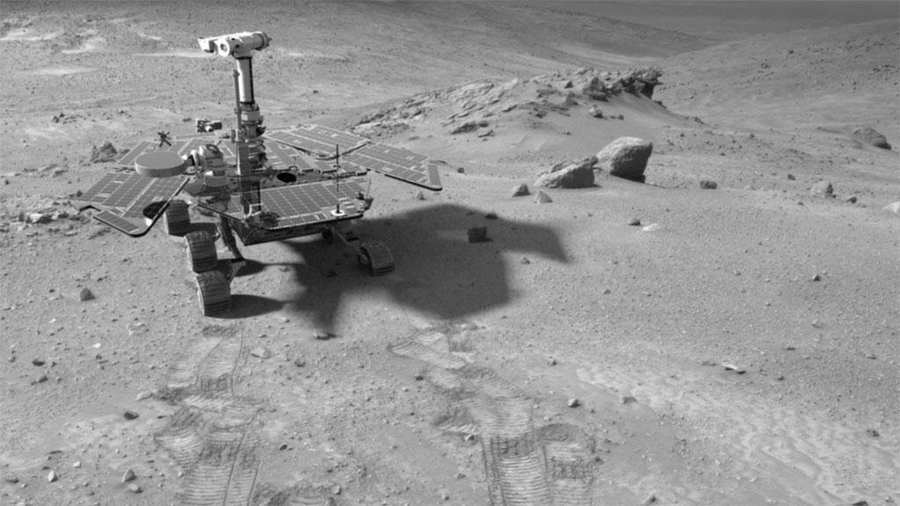
Spirit Rover in the Columbia Hills on Mars. Image credit: NASA/JPL-Caltech

Explain how the sensors you added will help achieve a scientific objective.

Example:
The proximity sensor added to the rover gives it the capability to determine if any objects exist near its path along the bright plains of Europa. Once such objects are located, the rover can turn toward them. Further use of the proximity sensor beyond this prototype include approaching the object to photograph it and determining when to take photographs. Each of these capabilities directly supports the scientific objective to photograph objects encountered on the plain once an object is detected.

In addition, the sensor can be used to avoid damaging an object through collision, or it might help the rover successfully navigate around obstacles.

Assessment Connection: Be sure to describe how the feature you are prototyping can support disaster recovery. You should also describe some of the other ways in which this sensor might benefit a disaster recovery effort. But make it clear that these are outside the scope of your prototype.

Optimization
Explain the robot’s goal-seeking approach by describing how optimization principles and concepts of reasoning, knowledge representation, uncertainty, and intelligence are implemented.

Example:
To increase optimization, the prototype makes use of CoppeliaSim's API calls instead of direct calculations in the code or having to make additional movements in the environment where possible. Additionally, for testing purposes, the prototype's movements were kept simplistic during the simulation, not requiring many additional calculations or path changes. You also must be careful of additional computation or conflicting actions made by child scripts (threaded versus non-threaded) during the simulation.
The rover makes decisions based on its reasoning about the environment. As the environment is unknown, the rover must rely on data from its two sensor types to reason about its actions. Its reasoning is based on logical decision-making; if an unknown object is detected and distant (it follows a path toward the object for exploration), if the object is close (it stops to take a picture), or if nothing is detected (it scans that area). The prototype uses its two sensor systems to gain knowledge of the environment through object detection. The sensors provide it with distance information and basic shape structure. Once close to an object, the rover can store images of its discoveries.
The rover's intelligence is based on its ability to carry out its goals. As the environment is unknown (and possibly changing), it must constantly search for objects of interest. Although limited in sensor range, it can move throughout the environment to find new objects. Once it makes a discovery, it can perform a behavior based on distance and location. As the prototype can respond based on any object type and in dynamic environments, it is able to perform in uncertain conditions and changes over time.

Assessment Connection: Be careful to accurately describe your robot's actual capabilities, and tie them concretely to goal seeking, optimization, knowledge, representation, uncertainty, and intelligence.

Prototyping

Describe specific, concrete criteria for assessing the success of the prototype rover for delivering the targeted feature and contributing to the overarching objective.

Example:
For the prototype to be considered successful, it needs to be able to accomplish its goal to detect and move toward objects. The following are some criteria to assess for success of the prototype:
- Is the prototype able to detect objects within 10 meters?
- Is the prototype able to turn and scan for more objects if none are found within 10 meters?
- After moving to an object there will be no objects closer than the one the prototype is facing.
- Does the prototype perform correctly in different environments?
- Does the rover exhibit unintended behaviors that interfere with its goals?

Assessment Connection: Keep in mind the capabilities and limitations of the CoppeliaSim environment in describing prototyping criteria.

Formulate a plan for testing these criteria within BubbleRob. Describe and implement your prototyping plan.

Example:
To provide environmental variety, the prototype is tested in three distinct environments:
- BubbleRob starts in the middle of a plane. Four cones are clustered near one another, 8 meters to BubbleRob’s left.
- BubbleRob starts at the top (12 o’clock) position of the simulated plane. Three spheres and six cubes are placed on the plane at varying distances (2 meters to 15 meters), including one cube directly ahead of BubbleRob (11 meters away).
- BubbleRob starts in the middle of a plane. Four cones are spaced out in the four quadrants around the rover, each 8 meters away.
By testing the rover in these sample environments, it is possible to gauge the effectiveness of its program in accomplishing its goals.

Assessment Connection: When you have completed your prototype tests, you have the option of going back and modifying BubbleRob based on what you learned. If you do so, make sure to rerun the tests and update the earlier sections of your submission to match your most current code.

Potential Enhancements
Describe potential future enhancements of your rover that go beyond what you have already built. Consider enhancements to the current feature as well as additional features that could be added.

Example:
There are several enhancements to the prototype that would further improve its performance. For instance, adding additional sensors and sensor types could improve its ability to detect various shapes and objects at further distances and its navigation ability. Additionally, changing the type of tires and rover shape could allow for better travel over more diverse and rugged terrain.

A potential additional feature would be attaching a drill component the rover can use to take samples for a more in-depth investigation. Another potential feature that would be beneficial is adding environmental mapping capabilities, so the rover can avoid exploring the same area repeatedly. This ability would add to its reasoning about the environment, so that it could explore additional areas.

Assessment Connection: This is another opportunity for you to demonstrate that the feature you have engineered contributes to a disaster relief scenario. You can also highlight specific further enhancements that will make BubbleRob into a more effective disaster relief robot.

Summarize at least one way in which reinforcement learning can optimize the rover's performance.
Reinforcement learning could optimize the rover's performance, especially for exploring an unknown environment. It can help the rover avoid exploring the same location repeatedly or getting stuck. Instead, a temporal or Monte Carlo method could be used to limit time spent in a particular area or to minimize exploring an area that is yielding limited objects. For instance, a rover on Europa will have a limited battery life. And I want it to explore areas of the surface where it can detect more objects rather than getting stuck exploring a void space. This feature would allow learned metadata about its new environment to be used to enhance its ability to carry out the more basic goals.

Assessment Connection: Building reinforcement learning into your robot might be too ambitious. Instead, focus on describing one or two concrete ways in which it could be leveraged to further disaster relief goals.

